**Assignment-3**

**Create IAM user and there by give full access of S3.**

**Steps for creating IAM user and giving full access for S3 permission:**

1. **Sign in.** Sign in as a root user. Provide username and password when prompted.
2. **Search on the search bar IAM. After that click on users in the IAM.**

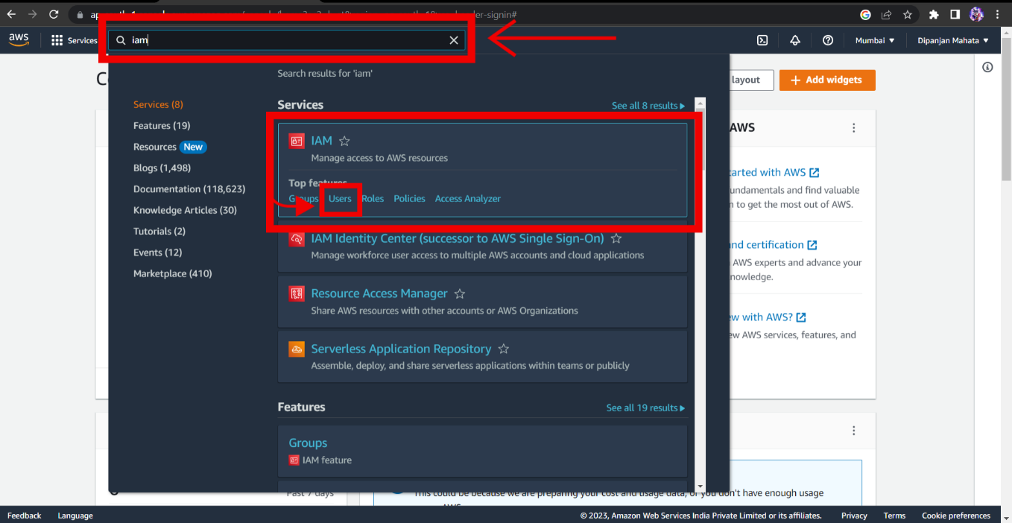

1. **Click on Add users.**

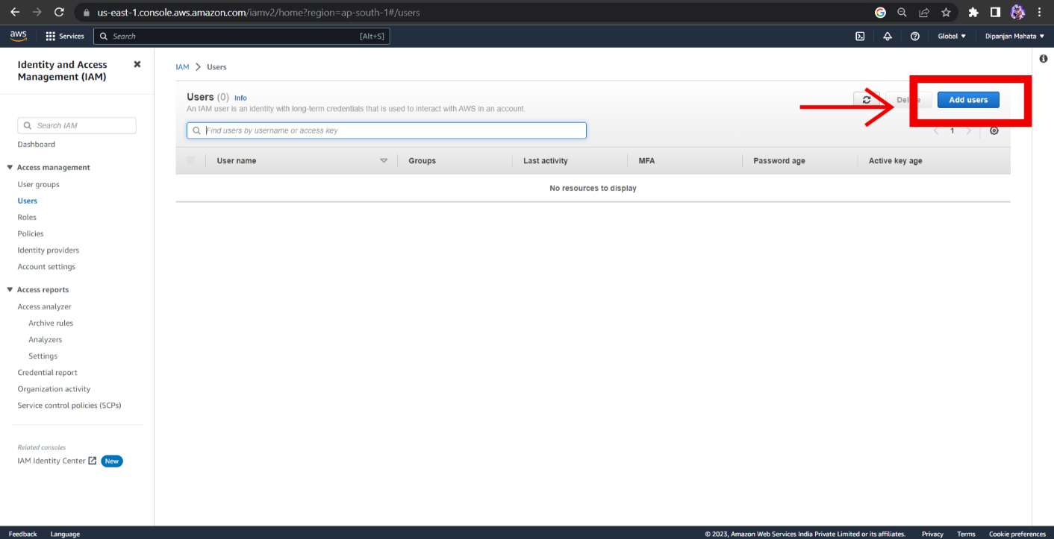

1. **After that enter IAM user name and click the check box below the User name.**

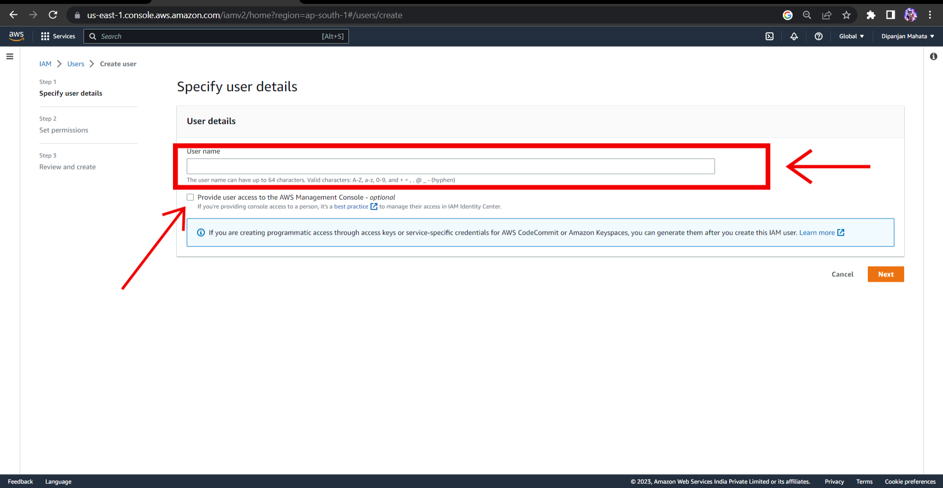

1. **Click on I want to create an IAM user. In the console password section click on custom password to set your IAM user password. After that click on the check box below the custom password and click Next.**

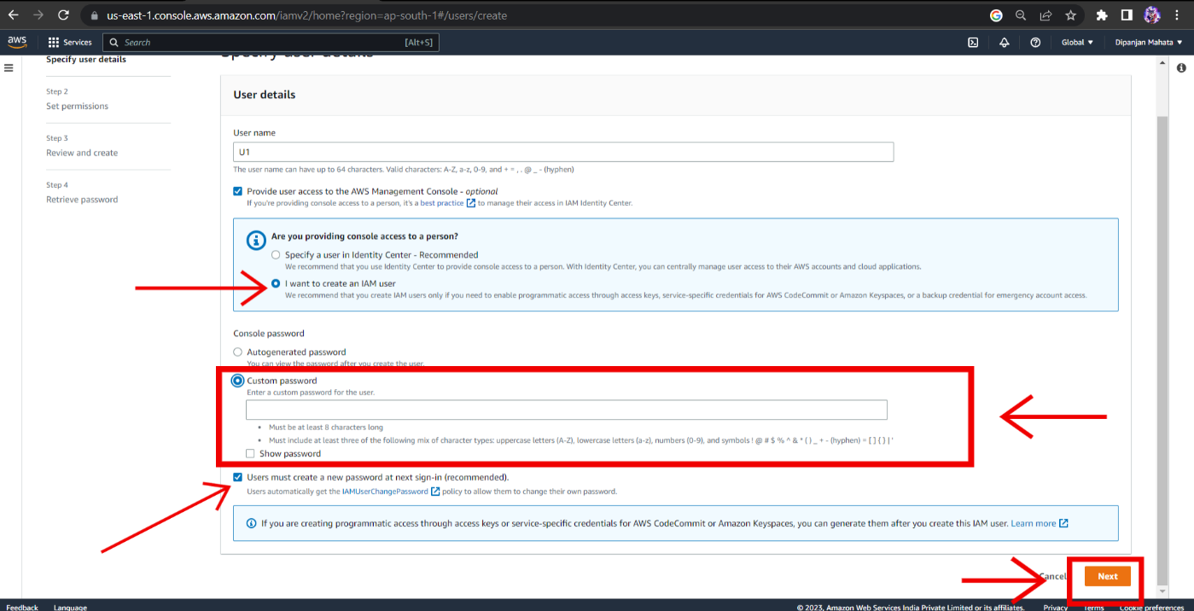

1. **Click on Create group.**

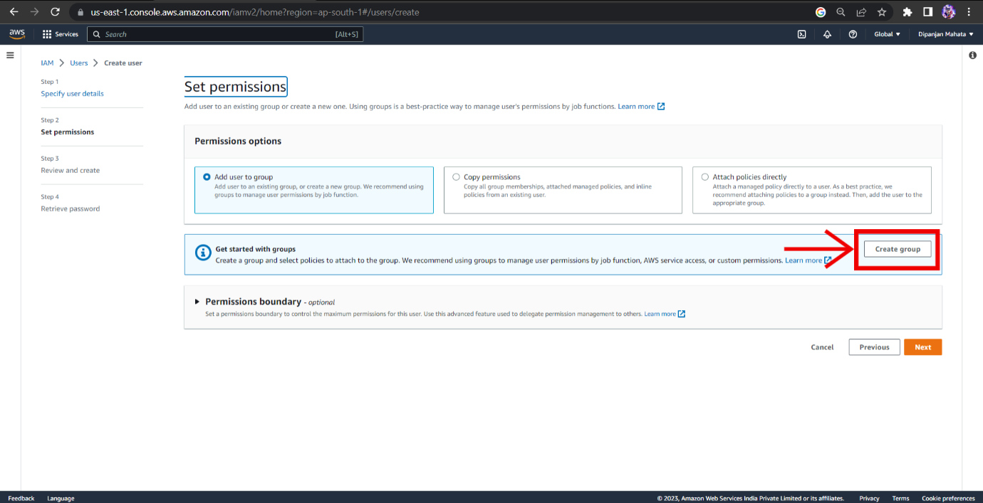

1. **Enter a group name. In the permission policies search S3 in and chick on the check box to select the Full access permission for S3. After that click Create group.**

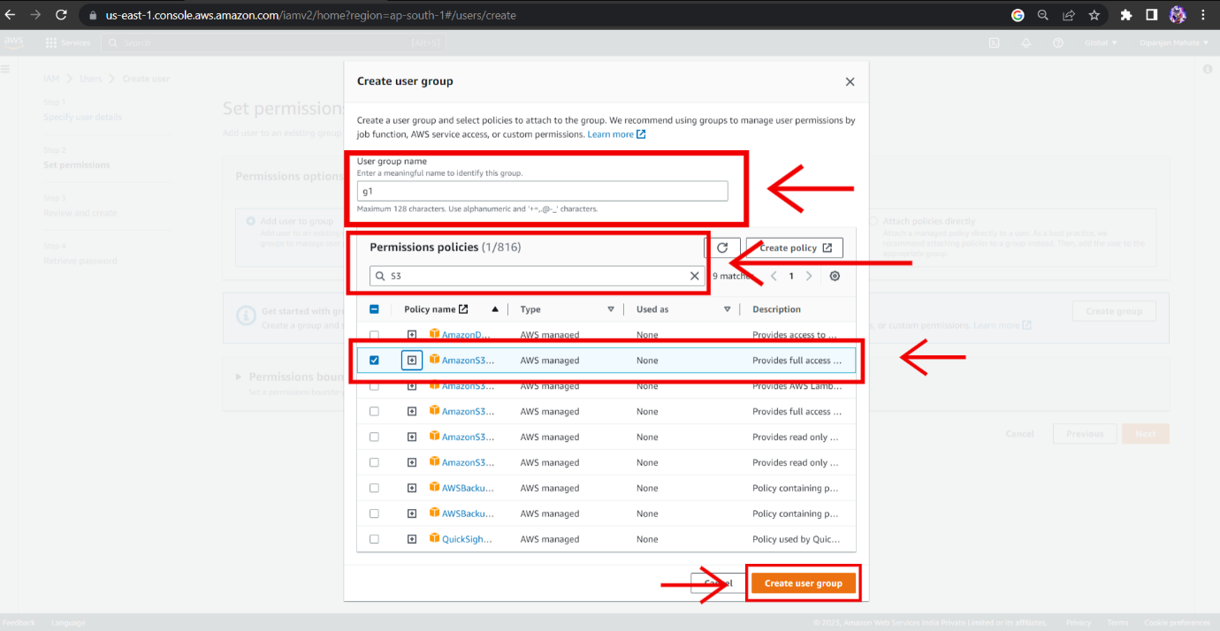

1. **Click on next.**

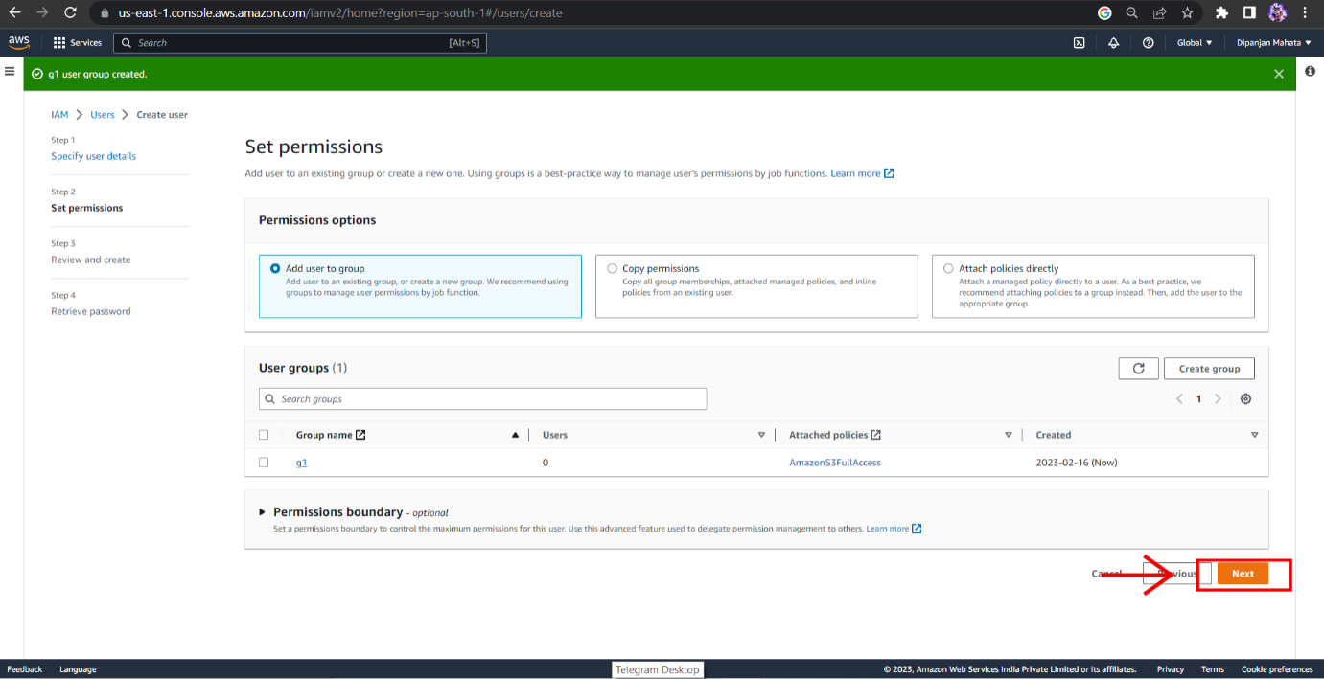

1. **After that review and click on Create user.**

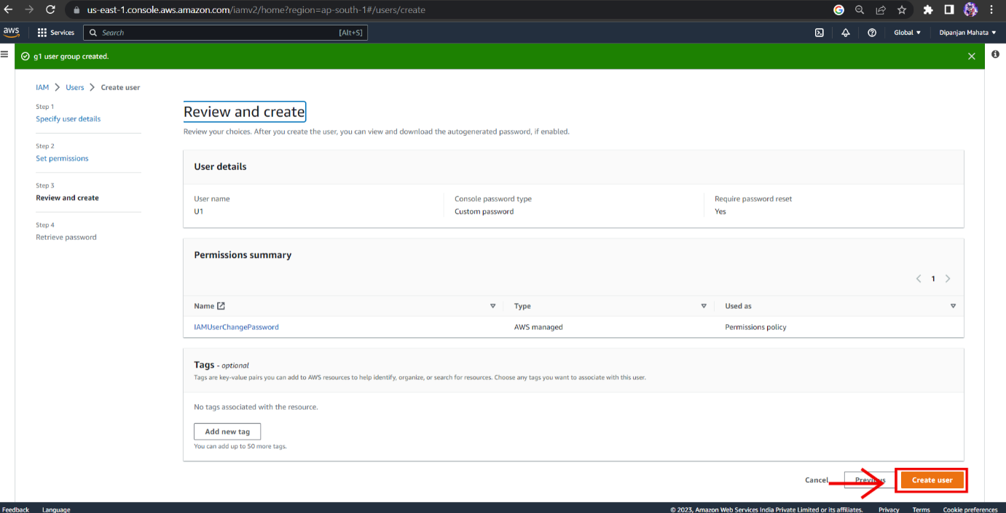

1. **Click on return to user list.**

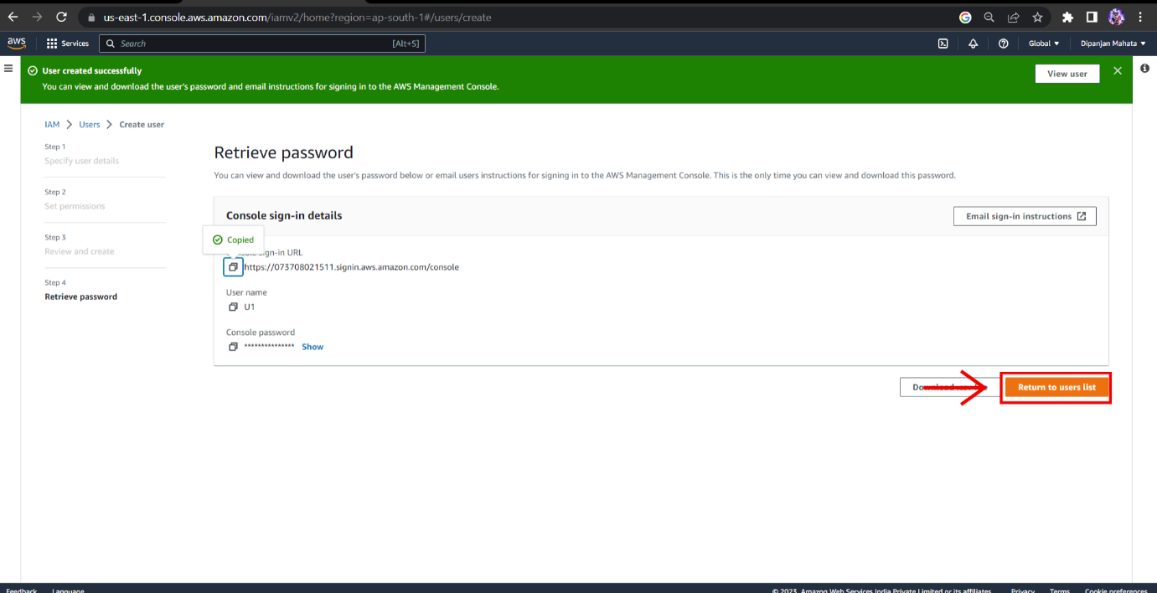

1. **Click on the group name.**

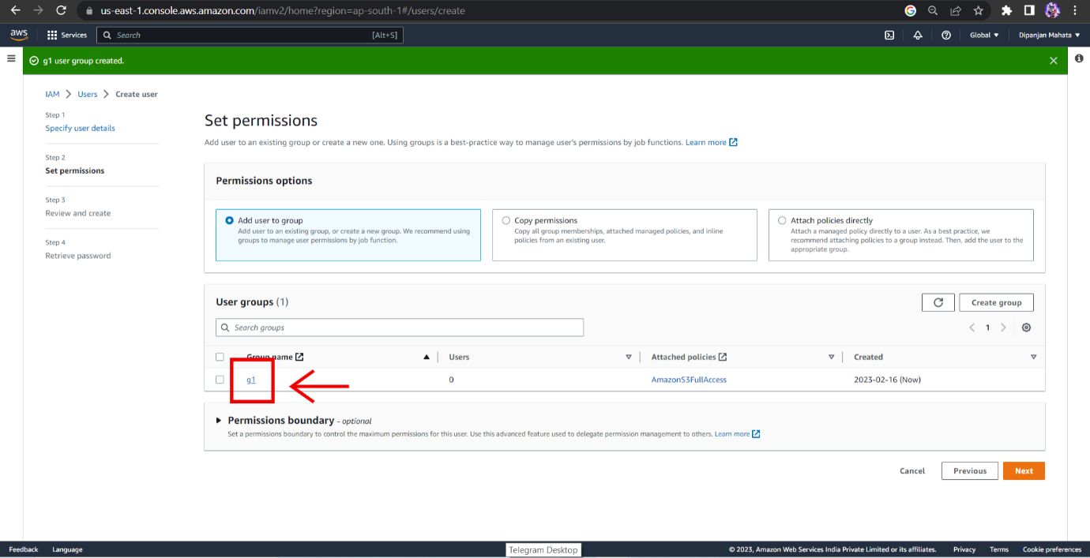

1. **Click on add users.**

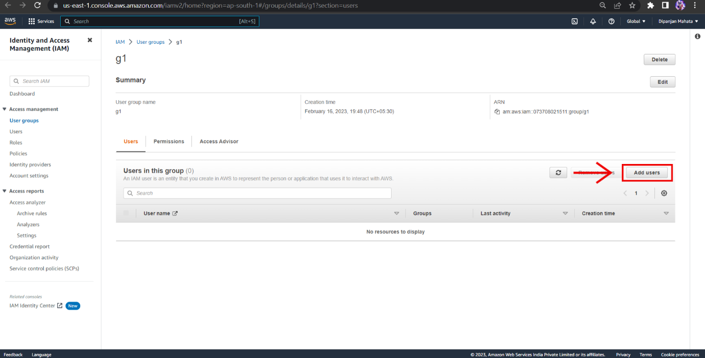

1. **Click the check box beside the user name to add the user in the group. After that click on add users.**

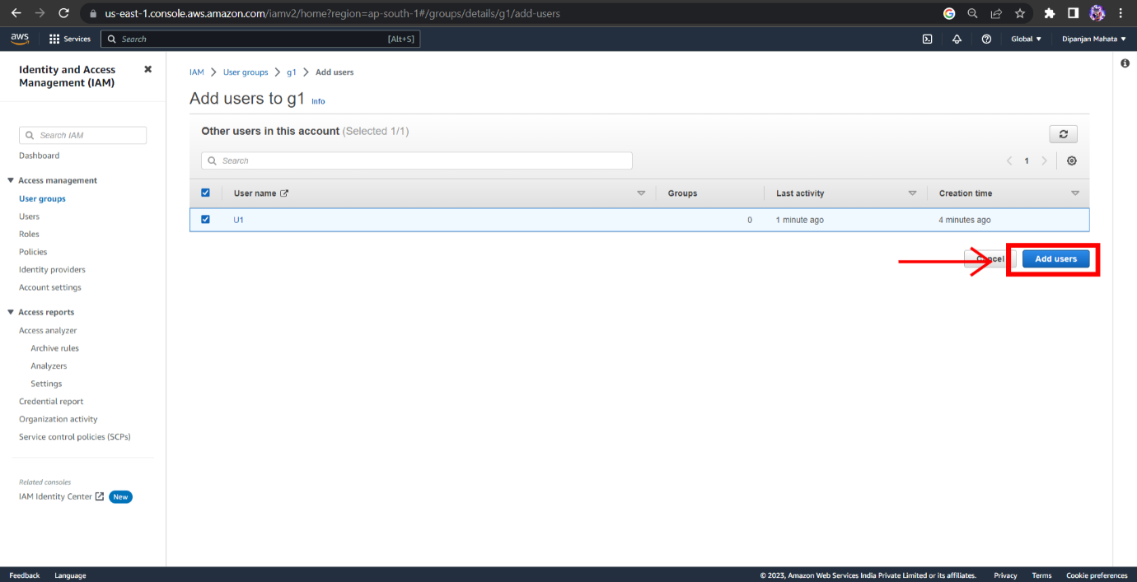

1. **After that login as IAM user and enter your Account ID(root user) and click on next.**

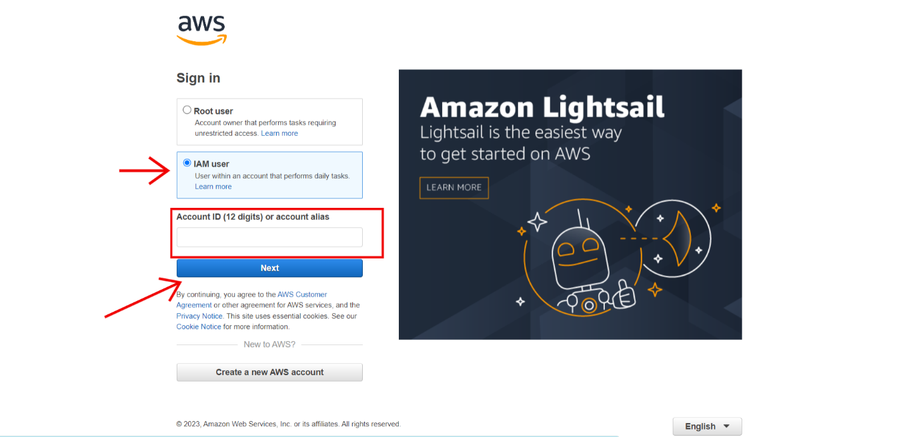

1. **Enter the user name you created and enter the password. Click Sign in.**

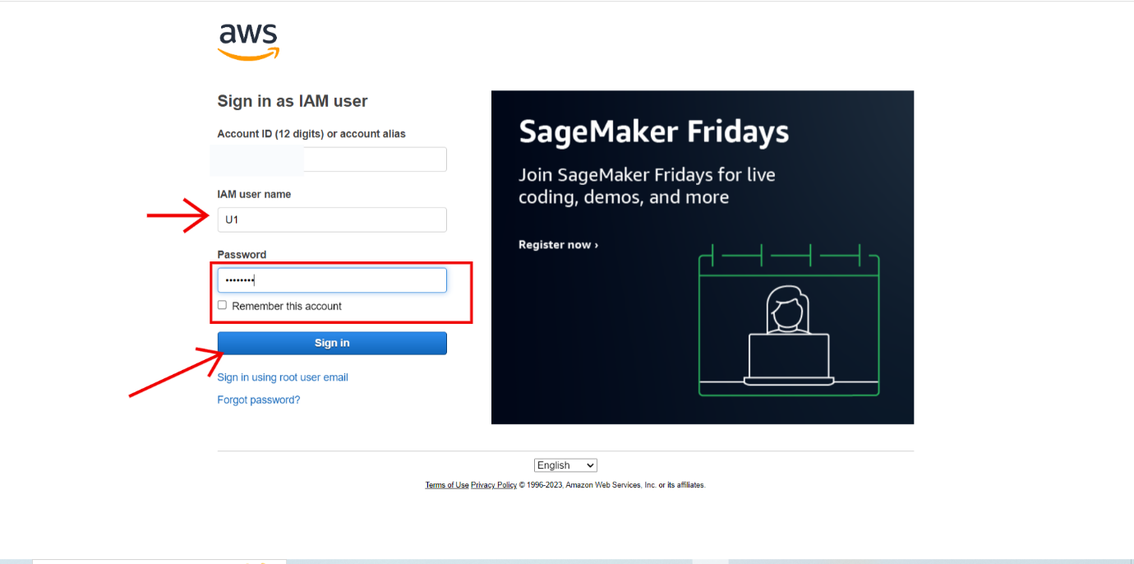

1. **Enter the password you have created and enter a new password. Click on create password change.**

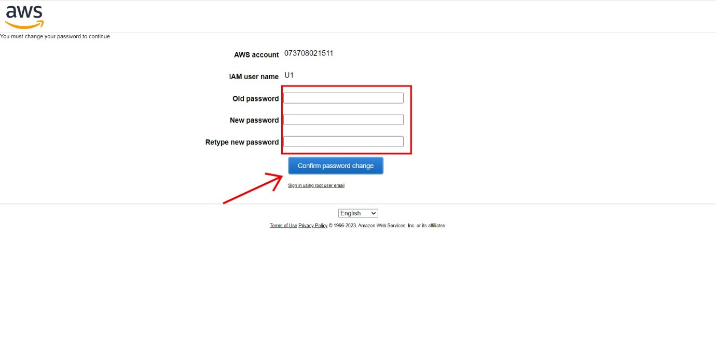

1. Now you are in the **IAM user**.